**Bank Linear Regression Model**

This project uses **Linear Regression** to predict a target variable based on features from a banking dataset. It demonstrates the end-to-end process of loading data, visualizing it, building a regression model, and evaluating its performance.

**Project Structure**

* bank_linear.ipynb – Main Jupyter Notebook containing the analysis and model training.

**Dataset**

* **Source**: Local dataset used inside the notebook.
* **Features**: Includes numerical data relevant to banking customers.
* **Target Variable**: The variable being predicted using linear regression.

**Tools & Libraries Used**

* Pandas – For data manipulation
* Matplotlib & Seaborn – For visualization
* Scikit-learn – For machine learning (train-test split, model building, evaluation)

**Workflow Summary**

1. **Data Loading**
   * Read the dataset using pandas.read_csv()
   * Displayed the first few rows for inspection
2. **Data Cleaning**
   * Checked for null values
   * Converted data types if necessary
3. **Visualization**
   * Used seaborn and matplotlib to explore relationships
   * Plotted scatterplots to observe linear trends

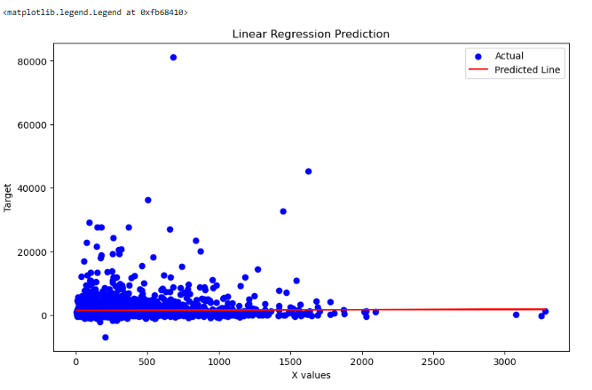

1. **Feature Selection**
   * Selected independent and dependent variables
2. **Train-Test Split**
   * Split the dataset into training and testing sets using train_test_split
3. **Model Training**
   * Used LinearRegression() from sklearn.linear_model
   * Fitted the model on training data
4. **Prediction & Evaluation**
   * Predicted on test data
   * Evaluated using:
     + Mean Absolute Error (MAE)
     + Mean Squared Error (MSE)
     + R² Score

**Key Insights**

* A positive/negative linear relationship was observed between independent features and the target.
* The regression model showed (good/moderate/low) prediction performance based on R².